**crimedata Atlanta-Session13 assignment2**

***varatharajan***

*July 17, 2018*

**Visualize the correlation between all variables in a meaningful and clear way of representing. Find out top 3 reasons for having more crime in a city.**

What is the difference between co-variance and correlation? Take an example from this dataset and show the differences if any?

COBRA_YTD2017<-read.csv('C:/Users/seshan/Desktop/COBRA-YTD2017.csv')

**require**(Amelia)

## Loading required package: Amelia

## Loading required package: Rcpp

## ##

## ## Amelia II: Multiple Imputation

## ## (Version 1.7.5, built: 2018-05-07)

## ## Copyright (C) 2005-2018 James Honaker, Gary King and Matthew Blackwell

## ## Refer to http://gking.harvard.edu/amelia/ for more information

## ##

**library**(Rcpp)

data<-COBRA_YTD2017

data[4:10,3] <- rep(NA,7)

data[1:5,4] <- NA

data <- data[-c(5,6)]

summary(data)

## MI_PRINX offense_id rpt_date

## Min. :8838438 Min. :1.608e+08 7/26/2017 : 106

## 1st Qu.:8904204 1st Qu.:1.711e+08 10/16/2017: 103

## Median :8910894 Median :1.720e+08 11/1/2017 : 103

## Mean :8910851 Mean :6.523e+08 9/21/2017 : 101

## 3rd Qu.:8917584 3rd Qu.:1.728e+08 11/28/2017: 100

## Max. :8924410 Max. :1.730e+11 (Other) :26239

## NA's : 7

## occur_date poss_time beat apt_office_prefix

## 11/17/2017: 110 8:00:00 : 526 Min. :101.0 :26213

## 10/7/2017 : 106 7:00:00 : 430 1st Qu.:208.0 APT : 314

## 8/19/2017 : 105 12:00:00: 426 Median :312.0 STE : 25

## 10/28/2017: 102 10:00:00: 376 Mean :355.6 ROOM : 21

## 10/31/2017: 99 9:00:00 : 376 3rd Qu.:505.0 BLDG : 12

## (Other) :26232 16:00:00: 375 Max. :710.0 UNIT : 12

## NA's : 5 (Other) :24250 (Other): 162

## apt_office_num location

## :22133 1801 HOWELL MILL RD NW : 142

## A : 120 3393 PEACHTREE RD NE @LENOX MALL : 140

## B : 108 1275 CAROLINE ST NE @TARGET - CAROLINE : 136

## 1 : 61 3393 PEACHTREE RD NE : 129

## 2 : 48 835 MARTIN L KING JR DR NW : 108

## 5 : 46 2841 GREENBRIAR PKWY SW @GREENBRIAR MALL: 95

## (Other): 4243 (Other) :26009

## MinOfucr MinOfibr_code dispo_code MaxOfnum_victims

## Min. :110.0 2305 :9024 :22959 Min. : 0.00

## 1st Qu.:521.0 2404 :2774 10 : 2893 1st Qu.: 1.00

## Median :640.0 2303 :2486 20 : 632 Median : 1.00

## Mean :598.8 2399 :1946 30 : 210 Mean : 1.16

## 3rd Qu.:660.0 2202 :1802 40 : 36 3rd Qu.: 1.00

## Max. :730.0 2308 :1381 60 : 20 Max. :27.00

## (Other):7346 (Other): 9 NA's :75

## Shift Avg.Day loc_type UC2.Literal

## Day :6882 Sat :3713 Min. : 1.00 LARCENY-FROM VEHICLE:9840

## Eve :9151 Sun :3569 1st Qu.:13.00 LARCENY-NON VEHICLE :6589

## Morn:7014 Tue :3542 Median :18.00 AUTO THEFT :3197

## Unk :3712 Wed :3539 Mean :20.76 BURGLARY-RESIDENCE :2635

## Mon :3492 3rd Qu.:20.00 AGG ASSAULT :2024

## Thu :3455 Max. :99.00 ROBBERY-PEDESTRIAN :1126

## (Other):5449 NA's :3344 (Other) :1348

## neighborhood npu x

## Downtown : 1828 M : 3077 Min. :-84.55

## Midtown : 1410 E : 2742 1st Qu.:-84.43

## : 1185 B : 2716 Median :-84.40

## Old Fourth Ward : 697 D : 1281 Mean :-83.69

## Lindbergh/Morosgo: 595 V : 1281 3rd Qu.:-84.37

## West End : 571 T : 1140 Max. : 0.00

## (Other) :20473 (Other):14522

## y

## Min. : 0.00

## 1st Qu.:33.73

## Median :33.76

## Mean :33.47

## 3rd Qu.:33.79

## Max. :33.88

##

pMiss <- **function**(x){sum(is.na(x))/length(x)*100}

apply(data,2,pMiss)

## MI_PRINX offense_id rpt_date occur_date

## 0.00000000 0.00000000 0.02615942 0.01868530

## poss_time beat apt_office_prefix apt_office_num

## 0.00000000 0.00000000 0.00000000 0.00000000

## location MinOfucr MinOfibr_code dispo_code

## 0.00000000 0.00000000 0.00000000 0.00000000

## MaxOfnum_victims Shift Avg.Day loc_type

## 0.28027953 0.00000000 0.00000000 12.49673007

## UC2.Literal neighborhood npu x

## 0.00000000 0.00000000 0.00000000 0.00000000

## y

## 0.00000000

apply(data,1,pMiss)

## [1] 4.761905 4.761905 4.761905 9.523810 9.523810 4.761905 4.761905

## [8] 4.761905 4.761905 4.761905 0.000000 4.761905 4.761905 0.000000

## [15] 0.000000 0.000000 0.000000 0.000000 0.000000 0.000000 0.000000

## [22] 0.000000 0.000000 0.000000 0.000000 0.000000 0.000000 0.000000

## [29] 0.000000 0.000000 0.000000 0.000000 0.000000 0.000000 0.000000

## [36] 0.000000 0.000000 0.000000 0.000000 0.000000 0.000000 0.000000

## [43] 0.000000 4.761905 0.000000 0.000000 0.000000 0.000000 0.000000

## [50] 0.000000 0.000000 0.000000 0.000000 0.000000 4.761905 0.000000

## [57] 0.000000 0.000000 0.000000 0.000000 0.000000 0.000000 0.000000

## [64] 0.000000 0.000000 0.000000 0.000000 0.000000 4.761905 0.000000

## [71] 4.761905 0.000000 0.000000 0.000000 0.000000 0.000000 0.000000

## [78] 4.761905 0.000000 0.000000 0.000000 0.000000 0.000000 0.000000

## [85] 0.000000 4.761905 0.000000 4.761905 0.000000 0.000000 0.000000

## [92] 4.761905 0.000000 0.000000 0.000000 4.761905 0.000000 4.761905

## [99] 0.000000 0.000000 4.761905 0.000000 0.000000 0.000000 0.000000

## [106] 0.000000 0.000000 0.000000 0.000000 0.000000 0.000000 0.000000

## [113] 0.000000 0.000000 0.000000 0.000000 0.000000 0.000000 0.000000

## [120] 4.761905 0.000000 0.000000 0.000000 0.000000 4.761905 0.000000

## [127] 0.000000 0.000000 0.000000 0.000000 0.000000 4.761905 0.000000

## [134] 0.000000 4.761905 4.761905 0.000000 0.000000 0.000000 0.000000

## [141] 0.000000 4.761905 0.000000 0.000000 0.000000 0.000000 0.000000

## [148] 0.000000 0.000000 4.761905 0.000000 0.000000 0.000000 0.000000

## [155] 0.000000 0.000000 0.000000 0.000000 0.000000 4.761905 4.761905

## [162] 0.000000 0.000000 0.000000 4.761905 0.000000 4.761905 4.761905

## [169] 0.000000 4.761905 0.000000 0.000000 4.761905 0.000000 0.000000

## [176] 4.761905 0.000000 0.000000 0.000000 0.000000 0.000000 0.000000

## [183] 0.000000 0.000000 0.000000 0.000000 0.000000 0.000000 0.000000

## [190] 0.000000 0.000000 0.000000 0.000000 0.000000 0.000000 0.000000

## [197] 0.000000 0.000000 0.000000 0.000000 0.000000 4.761905 0.000000

## [204] 0.000000 0.000000 0.000000 0.000000 0.000000 0.000000 0.000000

## [26419] 0.000000 0.000000 0.000000 0.000000 0.000000 0.000000 0.000000

## [26426] 0.000000 0.000000 0.000000 0.000000 0.000000 0.000000 0.000000

## [26433] 0.000000 0.000000 4.761905 0.000000 0.000000 4.761905 0.000000

## [26440] 0.000000 0.000000 0.000000 0.000000 0.000000 4.761905 0.000000

## [26447] 0.000000 0.000000 0.000000 0.000000 0.000000 0.000000 0.000000

## [26454] 0.000000 0.000000 0.000000 0.000000 4.761905 0.000000 0.000000

## [26461] 0.000000 0.000000 0.000000 0.000000 0.000000 4.761905 0.000000

## [26468] 0.000000 0.000000 0.000000 0.000000 0.000000 0.000000 4.761905

## [26475] 0.000000 0.000000 4.761905 0.000000 0.000000 0.000000 0.000000

## [26482] 0.000000 0.000000 0.000000 0.000000 0.000000 0.000000 0.000000

## [26489] 4.761905 4.761905 0.000000 0.000000 0.000000 4.761905 0.000000

## [26496] 0.000000 4.761905 0.000000 0.000000 4.761905 0.000000 0.000000

## [26503] 0.000000 0.000000 0.000000 0.000000 0.000000 4.761905 0.000000

## [26510] 0.000000 0.000000 0.000000 0.000000 0.000000 0.000000 0.000000

## [26517] 0.000000 0.000000 0.000000 0.000000 0.000000 0.000000 0.000000

## [26524] 0.000000 0.000000 0.000000 0.000000 0.000000 0.000000 0.000000

## [26531] 0.000000 0.000000 0.000000 0.000000 0.000000 4.761905 0.000000

## [26538] 4.761905 0.000000 0.000000 4.761905 0.000000 0.000000 0.000000

## [26545] 0.000000 0.000000 0.000000 0.000000 0.000000 4.761905 0.000000

## [26552] 0.000000 4.761905 0.000000 0.000000 0.000000 0.000000 0.000000

## [26559] 0.000000 0.000000 0.000000 0.000000 4.761905 0.000000 0.000000

## [26566] 0.000000 0.000000 0.000000 0.000000 0.000000 0.000000 0.000000

## [26573] 0.000000 0.000000 0.000000 0.000000 0.000000 0.000000 0.000000

## [26580] 0.000000 4.761905 0.000000 0.000000 0.000000 0.000000 0.000000

## [26587] 0.000000 0.000000 0.000000 0.000000 0.000000 0.000000 0.000000

## [26594] 0.000000 0.000000 0.000000 0.000000 0.000000 0.000000 0.000000

## [26601] 0.000000 0.000000 0.000000 0.000000 0.000000 0.000000 0.000000

## [26608] 0.000000 0.000000 0.000000 0.000000 0.000000 4.761905 0.000000

## [26615] 0.000000 0.000000 0.000000 0.000000 0.000000 0.000000 0.000000

## [26622] 0.000000 0.000000 0.000000 0.000000 0.000000 0.000000 0.000000

## [26629] 0.000000 0.000000 0.000000 0.000000 0.000000 0.000000 0.000000

## [26636] 0.000000 0.000000 0.000000 0.000000 0.000000 0.000000 0.000000

## [26643] 0.000000 0.000000 0.000000 4.761905 4.761905 0.000000 0.000000

## [26650] 0.000000 0.000000 0.000000 0.000000 4.761905 0.000000 0.000000

## [26657] 0.000000 0.000000 0.000000 4.761905 0.000000 0.000000 0.000000

## [26664] 4.761905 0.000000 0.000000 0.000000 0.000000 0.000000 0.000000

## [26671] 0.000000 0.000000 0.000000 0.000000 0.000000 4.761905 0.000000

## [26678] 9.523810 4.761905 0.000000 0.000000 4.761905 0.000000 4.761905

## [26685] 0.000000 0.000000 0.000000 0.000000 0.000000 0.000000 0.000000

## [26692] 0.000000 0.000000 0.000000 0.000000 0.000000 0.000000 0.000000

## [26699] 0.000000 0.000000 0.000000 0.000000 0.000000 0.000000 0.000000

## [26706] 4.761905 0.000000 0.000000 0.000000 0.000000 4.761905 0.000000

## [26713] 0.000000 0.000000 0.000000 0.000000 0.000000 0.000000 0.000000

## [26720] 0.000000 0.000000 0.000000 0.000000 4.761905 0.000000 0.000000

## [26727] 0.000000 0.000000 0.000000 0.000000 0.000000 0.000000 0.000000

## [26734] 0.000000 0.000000 0.000000 0.000000 0.000000 0.000000 0.000000

## [26741] 0.000000 0.000000 0.000000 4.761905 0.000000 4.761905 0.000000

## [26748] 0.000000 0.000000 0.000000 0.000000 0.000000 0.000000 0.000000

## [26755] 0.000000 0.000000 0.000000 0.000000 0.000000

**library**(mice)

## Warning: package 'mice' was built under R version 3.5.1

## Loading required package: lattice

##

## Attaching package: 'mice'

## The following objects are masked from 'package:base':

##

## cbind, rbind

md.pattern(data)

## MI_PRINX offense_id poss_time beat apt_office_prefix apt_office_num

## 23405 1 1 1 1 1 1

## 3269 1 1 1 1 1 1

## 75 1 1 1 1 1 1

## 5 1 1 1 1 1 1

## 3 1 1 1 1 1 1

## 2 1 1 1 1 1 1

## 0 0 0 0 0 0

## location MinOfucr MinOfibr_code dispo_code Shift Avg.Day UC2.Literal

## 23405 1 1 1 1 1 1 1

## 3269 1 1 1 1 1 1 1

## 75 1 1 1 1 1 1 1

## 5 1 1 1 1 1 1 1

## 3 1 1 1 1 1 1 1

## 2 1 1 1 1 1 1 1

## 0 0 0 0 0 0 0

## neighborhood npu x y occur_date rpt_date MaxOfnum_victims loc_type

## 23405 1 1 1 1 1 1 1 1

## 3269 1 1 1 1 1 1 1 0

## 75 1 1 1 1 1 1 0 0

## 5 1 1 1 1 1 0 1 1

## 3 1 1 1 1 0 1 1 1

## 2 1 1 1 1 0 0 1 1

## 0 0 0 0 5 7 75 3344

##

## 23405 0

## 3269 1

## 75 2

## 5 1

## 3 1

## 2 2

## 3431

**library**(VIM)

## Warning: package 'VIM' was built under R version 3.5.1

## Loading required package: colorspace

## Loading required package: grid

## Loading required package: data.table

## VIM is ready to use.

## Since version 4.0.0 the GUI is in its own package VIMGUI.

##

## Please use the package to use the new (and old) GUI.

## Suggestions and bug-reports can be submitted at: https://github.com/alexkowa/VIM/issues

##

## Attaching package: 'VIM'

## The following object is masked from 'package:datasets':

##

## sleep

aggr_plot <- aggr(data, col=c('navyblue','red'), numbers=TRUE, sortVars=TRUE, labels=names(data), cex.axis=.7, gap=3, ylab=c("Histogram of missing data","Pattern"))

## Warning in plot.aggr(res, ...): not enough horizontal space to display

## frequencies

##

## Variables sorted by number of missings:

## Variable Count

## loc_type 0.1249673007

## MaxOfnum_victims 0.0028027953

## rpt_date 0.0002615942

## occur_date 0.0001868530

## MI_PRINX 0.0000000000

## offense_id 0.0000000000

## poss_time 0.0000000000

## beat 0.0000000000

## apt_office_prefix 0.0000000000

## apt_office_num 0.0000000000

## location 0.0000000000

## MinOfucr 0.0000000000

## MinOfibr_code 0.0000000000

## dispo_code 0.0000000000

## Shift 0.0000000000

## Avg.Day 0.0000000000

## UC2.Literal 0.0000000000

## neighborhood 0.0000000000

## npu 0.0000000000

## x 0.0000000000

## y 0.0000000000

marginplot(data[c(1,2)])

*# All below charts provide the visualization of missing data in the data set*

m <- matrix(data=cbind(rnorm(30, 0), rnorm(30, 2), rnorm(30, 5)), nrow=30, ncol=3)

apply(m, 1, mean)

## [1] 3.6966102 2.5742466 2.7391286 2.1355486 2.0897085 2.2097172 2.5066403

## [8] 1.3674533 1.2135926 2.3049017 1.5394682 2.4264711 2.3560555 1.4429536

## [15] 1.9525326 2.8921570 2.8218232 2.0948454 2.9282604 1.6813430 2.8007640

## [22] 2.4313354 2.7598386 2.5998863 3.1127215 2.0842223 1.5925865 0.5778122

## [29] 2.3238416 1.2541749

apply(m, 2, **function**(x) length(x[x<0]))

## [1] 14 0 0

apply(m, 2, **function**(x) is.matrix(x))

## [1] FALSE FALSE FALSE

apply(m, 2, is.vector)

## [1] TRUE TRUE TRUE

apply(m, 2, **function**(x) mean(x[x>0]))

## [1] 0.5386839 1.9773260 4.7891772

sapply(1:3, **function**(x) x^2)

## [1] 1 4 9

lapply(1:3, **function**(x) x^2)

## [[1]]

## [1] 1

##

## [[2]]

## [1] 4

##

## [[3]]

## [1] 9

sapply(1:3, **function**(x) mean(m[,x]))

## [1] -0.1154391 1.9773260 4.7891772

sapply(1:3, **function**(x, y) mean(y[,x]), y=m)

## [1] -0.1154391 1.9773260 4.7891772

**library**(tidyverse)

## -- Attaching packages --------------------------------------------- tidyverse 1.2.1 --

## v ggplot2 3.0.0 v purrr 0.2.5

## v tibble 1.4.2 v dplyr 0.7.6

## v tidyr 0.8.1 v stringr 1.3.1

## v readr 1.1.1 v forcats 0.3.0

## -- Conflicts ------------------------------------------------ tidyverse_conflicts() --

## x dplyr::between() masks data.table::between()

## x tidyr::complete() masks mice::complete()

## x dplyr::filter() masks stats::filter()

## x dplyr::first() masks data.table::first()

## x dplyr::lag() masks stats::lag()

## x dplyr::last() masks data.table::last()

## x purrr::transpose() masks data.table::transpose()

**library**(ggmap)

## Warning: package 'ggmap' was built under R version 3.5.1

**library**(readxl)

**library**(kableExtra)

## Warning: package 'kableExtra' was built under R version 3.5.1

**library**(knitr)

str(COBRA_YTD2017)

## 'data.frame': 26759 obs. of 23 variables:

## $ MI_PRINX : int 8924155 8924156 8924157 8924158 8924159 8924160 8924161 8924162 8924163 8924164 ...

## $ offense_id : num 1.74e+08 1.74e+08 1.74e+08 1.74e+08 1.74e+08 ...

## $ rpt_date : Factor w/ 365 levels "1/1/2017","1/10/2017",..: 117 117 117 117 117 117 117 117 117 117 ...

## $ occur_date : Factor w/ 471 levels "1/1/2008","1/1/2015",..: 174 145 174 174 176 174 176 176 174 176 ...

## $ occur_time : Factor w/ 1355 levels "","0:00:00","0:01:00",..: 955 290 883 763 43 940 112 2 2 2 ...

## $ poss_date : Factor w/ 412 levels "1/1/2015","1/1/2017",..: 147 145 147 147 147 147 147 147 147 147 ...

## $ poss_time : Factor w/ 1434 levels "","0:00:00","0:01:00",..: 32 902 62 68 50 88 121 722 1024 1056 ...

## $ beat : int 510 501 303 507 409 612 605 603 605 304 ...

## $ apt_office_prefix: Factor w/ 88 levels "","#8","1","10",..: 1 1 1 1 1 1 1 1 1 1 ...

## $ apt_office_num : Factor w/ 2044 levels "","#5","]","`",..: 1 1 1 1 1 1 213 1 1 1372 ...

## $ location : Factor w/ 13865 levels ": 565 Main St NE",..: 9394 1133 10955 7860 5557 1525 8250 9706 9456 455 ...

## $ MinOfucr : int 640 640 640 640 640 650 311 640 640 531 ...

## $ MinOfibr_code : Factor w/ 68 levels "","1101","1101A",..: 51 51 51 51 51 50 30 51 51 42 ...

## $ dispo_code : Factor w/ 8 levels "","10","20","30",..: 1 1 1 1 1 1 1 1 1 1 ...

## $ MaxOfnum_victims : int 2 1 1 1 2 1 1 1 1 1 ...

## $ Shift : Factor w/ 4 levels "Day","Eve","Morn",..: 3 4 3 2 3 3 3 3 4 3 ...

## $ Avg.Day : Factor w/ 8 levels "Fri","Mon","Sat",..: 3 7 3 3 4 4 4 4 3 4 ...

## $ loc_type : int 13 13 18 18 18 18 26 18 13 26 ...

## $ UC2.Literal : Factor w/ 11 levels "AGG ASSAULT",..: 6 6 6 6 6 6 10 6 6 4 ...

## $ neighborhood : Factor w/ 239 levels "","Adair Park",..: 80 117 145 64 3 83 103 164 103 175 ...

## $ npu : Factor w/ 26 levels "","A","B","C",..: 14 6 22 14 19 23 23 14 23 22 ...

## $ x : num -84.4 -84.4 -84.4 -84.4 -84.5 ...

## $ y : num 33.8 33.8 33.7 33.8 33.7 ...

COBRA_YTD2017$long <- COBRA_YTD2017$x %>%

as.numeric()

COBRA_YTD2017$lat <- COBRA_YTD2017$y %>%

as.numeric()

COBRA_YTD2017$loc_type <- COBRA_YTD2017$UC2.Literal %>% as.factor()

COBRA_YTD2017$days <- COBRA_YTD2017$Avg.Day %>%

as.factor()

kable(count(COBRA_YTD2017, loc_type, sort=TRUE), "html", col.names=c("Crime Type", "Frequency")) %>%

kable_styling(bootstrap_options="striped", full_width=FALSE)

| **Crime Type** | **Frequency** |
| --- | --- |
| LARCENY-FROM VEHICLE | 9840 |
| LARCENY-NON VEHICLE | 6589 |
| AUTO THEFT | 3197 |
| BURGLARY-RESIDENCE | 2635 |
| AGG ASSAULT | 2024 |
| ROBBERY-PEDESTRIAN | 1126 |
| BURGLARY-NONRES | 758 |
| RAPE | 226 |
| ROBBERY-COMMERCIAL | 157 |
| ROBBERY-RESIDENCE | 132 |
| HOMICIDE | 75 |

COBRA_YTD2017 %>%

group_by(days, loc_type) %>%

summarize(freq=n()) %>%

ggplot(aes(reorder(days, -freq), freq)) +

geom_bar(aes(fill=loc_type), position="dodge", stat="identity", width=0.8, color="black") +

xlab("Day of Week") +

ylab("Frequency") +

labs(fill="Crime Type") +

ggtitle("Crime by Day of the Week")

kable

## function (x, format, digits = getOption("digits"), row.names = NA,

## col.names = NA, align, caption = NULL, format.args = list(),

## escape = TRUE, ...)

## {

## if (missing(format) || is.null(format))

## format = getOption("knitr.table.format")

## if (is.null(format))

## format = if (is.null(pandoc_to()))

## switch(out_format() %n% "markdown", latex = "latex",

## listings = "latex", sweave = "latex", html = "html",

## markdown = "markdown", rst = "rst", stop("table format not implemented yet!"))

## else if (isTRUE(opts_knit$get("kable.force.latex")) &&

## is_latex_output()) {

## "latex"

## }

## else "pandoc"

## if (is.function(format))

## format = format()

## if (format != "latex" && !missing(align) && length(align) ==

## 1L)

## align = strsplit(align, "")[[1]]

## if (!is.null(caption) && !is.na(caption))

## caption = paste0(create_label("tab:", opts_current$get("label"),

## latex = (format == "latex")), caption)

## if (inherits(x, "list")) {

## if (format == "pandoc" && is_latex_output())

## format = "latex"

## res = lapply(x, kable, format = format, digits = digits,

## row.names = row.names, col.names = col.names, align = align,

## caption = NA, format.args = format.args, escape = escape,

## ...)

## res = unlist(lapply(res, paste, collapse = "\n"))

## res = if (format == "latex") {

## kable_latex_caption(res, caption)

## }

## else if (format == "html" || (format == "pandoc" && is_html_output()))

## kable_html(matrix(paste0("\n\n", res, "\n\n"), 1),

## caption = caption, escape = FALSE, table.attr = "class=\"kable_wrapper\"")

## else {

## res = paste(res, collapse = "\n\n")

## if (format == "pandoc")

## kable_pandoc_caption(res, caption)

## else res

## }

## return(structure(res, format = format, class = "knitr_kable"))

## }

## if (!is.matrix(x))

## x = as.data.frame(x)

## if (identical(col.names, NA))

## col.names = colnames(x)

## m = ncol(x)

## isn = if (is.matrix(x))

## rep(is.numeric(x), m)

## else sapply(x, is.numeric)

## if (missing(align) || (format == "latex" && is.null(align)))

## align = ifelse(isn, "r", "l")

## digits = rep(digits, length.out = m)

## for (j in seq_len(m)) {

## if (is_numeric(x[, j]))

## x[, j] = round(x[, j], digits[j])

## }

## if (any(isn)) {

## if (is.matrix(x)) {

## if (is.table(x) && length(dim(x)) == 2)

## class(x) = "matrix"

## x = format_matrix(x, format.args)

## }

## else x[, isn] = format_args(x[, isn], format.args)

## }

## if (is.na(row.names))

## row.names = has_rownames(x)

## if (!is.null(align))

## align = rep(align, length.out = m)

## if (row.names) {

## x = cbind(` ` = rownames(x), x)

## if (!is.null(col.names))

## col.names = c(" ", col.names)

## if (!is.null(align))

## align = c("l", align)

## }

## n = nrow(x)

## x = replace_na(to_character(as.matrix(x)), is.na(x))

## if (!is.matrix(x))

## x = matrix(x, nrow = n)

## x = trimws(x)

## colnames(x) = col.names

## if (format != "latex" && length(align) && !all(align %in%

## c("l", "r", "c")))

## stop("'align' must be a character vector of possible values 'l', 'r', and 'c'")

## attr(x, "align") = align

## res = do.call(paste("kable", format, sep = "_"), list(x = x,

## caption = caption, escape = escape, ...))

## structure(res, format = format, class = "knitr_kable")

## }

## <bytecode: 0x0000000024a52558>

## <environment: namespace:knitr>

*#The data provides crime type frequency and crime by day of the week.#Among the high crime categories, larceny tend to increase on Fridays and Saturdays. while burglary residence generally occurred more often during the weekdays than the weekends. Auto theft were least reported on Thursdays and increase for the weekends.*

atlanta_map <- qmap("atlanta",

zoom=12,

**source**="stamen",

maptype="toner",

color="bw")

## Map from URL : http://maps.googleapis.com/maps/api/staticmap?center=atlanta&zoom=12&size=640x640&scale=2&maptype=terrain&sensor=false

## Information from URL : http://maps.googleapis.com/maps/api/geocode/json?address=atlanta&sensor=false

## Map from URL : http://tile.stamen.com/toner/12/1086/1638.png

## Map from URL : http://tile.stamen.com/toner/12/1087/1638.png

## Map from URL : http://tile.stamen.com/toner/12/1088/1638.png

## Map from URL : http://tile.stamen.com/toner/12/1089/1638.png

## Map from URL : http://tile.stamen.com/toner/12/1086/1639.png

## Map from URL : http://tile.stamen.com/toner/12/1087/1639.png

## Map from URL : http://tile.stamen.com/toner/12/1088/1639.png

## Map from URL : http://tile.stamen.com/toner/12/1089/1639.png

## Map from URL : http://tile.stamen.com/toner/12/1086/1640.png

## Map from URL : http://tile.stamen.com/toner/12/1087/1640.png

## Map from URL : http://tile.stamen.com/toner/12/1088/1640.png

## Map from URL : http://tile.stamen.com/toner/12/1089/1640.png

## Warning: `panel.margin` is deprecated. Please use `panel.spacing` property

## instead

atlanta_map

## Theme element panel.border missing

## Theme element axis.line.x.bottom missing

## Theme element axis.ticks.x.bottom missing

## Theme element axis.line.x.top missing

## Theme element axis.ticks.x.top missing

## Theme element axis.line.y.left missing

## Theme element axis.ticks.y.left missing

## Theme element axis.line.y.right missing

## Theme element axis.ticks.y.right missing

## Theme element plot.title missing

## Theme element plot.subtitle missing

## Theme element plot.tag missing

## Theme element plot.caption missing

**library**(dplyr)

**library**(data.table)

**library**(ggplot2)

at <- COBRA_YTD2017

str(at)

## 'data.frame': 26759 obs. of 26 variables:

## $ MI_PRINX : int 8924155 8924156 8924157 8924158 8924159 8924160 8924161 8924162 8924163 8924164 ...

## $ offense_id : num 1.74e+08 1.74e+08 1.74e+08 1.74e+08 1.74e+08 ...

## $ rpt_date : Factor w/ 365 levels "1/1/2017","1/10/2017",..: 117 117 117 117 117 117 117 117 117 117 ...

## $ occur_date : Factor w/ 471 levels "1/1/2008","1/1/2015",..: 174 145 174 174 176 174 176 176 174 176 ...

## $ occur_time : Factor w/ 1355 levels "","0:00:00","0:01:00",..: 955 290 883 763 43 940 112 2 2 2 ...

## $ poss_date : Factor w/ 412 levels "1/1/2015","1/1/2017",..: 147 145 147 147 147 147 147 147 147 147 ...

## $ poss_time : Factor w/ 1434 levels "","0:00:00","0:01:00",..: 32 902 62 68 50 88 121 722 1024 1056 ...

## $ beat : int 510 501 303 507 409 612 605 603 605 304 ...

## $ apt_office_prefix: Factor w/ 88 levels "","#8","1","10",..: 1 1 1 1 1 1 1 1 1 1 ...

## $ apt_office_num : Factor w/ 2044 levels "","#5","]","`",..: 1 1 1 1 1 1 213 1 1 1372 ...

## $ location : Factor w/ 13865 levels ": 565 Main St NE",..: 9394 1133 10955 7860 5557 1525 8250 9706 9456 455 ...

## $ MinOfucr : int 640 640 640 640 640 650 311 640 640 531 ...

## $ MinOfibr_code : Factor w/ 68 levels "","1101","1101A",..: 51 51 51 51 51 50 30 51 51 42 ...

## $ dispo_code : Factor w/ 8 levels "","10","20","30",..: 1 1 1 1 1 1 1 1 1 1 ...

## $ MaxOfnum_victims : int 2 1 1 1 2 1 1 1 1 1 ...

## $ Shift : Factor w/ 4 levels "Day","Eve","Morn",..: 3 4 3 2 3 3 3 3 4 3 ...

## $ Avg.Day : Factor w/ 8 levels "Fri","Mon","Sat",..: 3 7 3 3 4 4 4 4 3 4 ...

## $ loc_type : Factor w/ 11 levels "AGG ASSAULT",..: 6 6 6 6 6 6 10 6 6 4 ...

## $ UC2.Literal : Factor w/ 11 levels "AGG ASSAULT",..: 6 6 6 6 6 6 10 6 6 4 ...

## $ neighborhood : Factor w/ 239 levels "","Adair Park",..: 80 117 145 64 3 83 103 164 103 175 ...

## $ npu : Factor w/ 26 levels "","A","B","C",..: 14 6 22 14 19 23 23 14 23 22 ...

## $ x : num -84.4 -84.4 -84.4 -84.4 -84.5 ...

## $ y : num 33.8 33.8 33.7 33.8 33.7 ...

## $ long : num -84.4 -84.4 -84.4 -84.4 -84.5 ...

## $ lat : num 33.8 33.8 33.7 33.8 33.7 ...

## $ days : Factor w/ 8 levels "Fri","Mon","Sat",..: 3 7 3 3 4 4 4 4 3 4 ...

at$MI_PRINX <- at$apt_office_prefix <- at$apt_office_num <- at$location <- at$dispo_code <- at$loc_type <- at$npu <- NULL

**library**(chron)

**library**(lubridate)

##

## Attaching package: 'lubridate'

## The following objects are masked from 'package:chron':

##

## days, hours, minutes, seconds, years

## The following objects are masked from 'package:data.table':

##

## hour, isoweek, mday, minute, month, quarter, second, wday,

## week, yday, year

## The following object is masked from 'package:base':

##

## date

at$lon <- at$x

at$lat <- at$y

at$occur_date <- mdy(at$occur_date)

at$rpt_date <- mdy(at$rpt_date)

at$occur_time <- chron(times=at$occur_time)

at$lon <- as.numeric(at$lon)

at$lat <- as.numeric(at$lat)

at$x <- at$y <- NULL

**library**(xts)

## Loading required package: zoo

##

## Attaching package: 'zoo'

## The following objects are masked from 'package:base':

##

## as.Date, as.Date.numeric

##

## Attaching package: 'xts'

## The following objects are masked from 'package:dplyr':

##

## first, last

## The following objects are masked from 'package:data.table':

##

## first, last

by_Date <- na.omit(at) %>% group_by(occur_date) %>% summarise(Total = n())

tseries <- xts(by_Date$Total, order.by= by_Date$occur_date)

**library**(highcharter)

## Warning: package 'highcharter' was built under R version 3.5.1

## Highcharts (www.highcharts.com) is a Highsoft software product which is

## not free for commercial and Governmental use

hchart(tseries, name = "Crimes") %>%

hc_add_theme(hc_theme_darkunica()) %>%

hc_credits(enabled = TRUE, text = "Sources: Atlanta Police Department", style = list(fontSize = "12px")) %>%

hc_title(text = "Time Series of Atlanta Crimes") %>%

hc_legend(enabled = TRUE)



Zoom1m3m6mYTD1yAllFromDec 30, 1916ToDec 31, 2017Time Series of Atlanta CrimesCrimes201620160255075100125Sources: Atlanta Police Department

hchart

## function (object, ...)

## {

## UseMethod("hchart")

## }

## <bytecode: 0x0000000021bb6d30>

## <environment: namespace:highcharter>

*#Graph provides the data spread of the crime during the year*

at$dayofWeek <- weekdays(as.Date(at$occur_date))

at$hour <- sub(":.*", "", at$occur_time)

at$hour <- as.numeric(at$hour)

ggplot(aes(x = hour), data = at) + geom_histogram(bins = 24, color='white', fill='black') +

ggtitle('Histogram of Crime Time')

## Warning: Removed 11 rows containing non-finite values (stat_bin).

*#The crime time distribution appears bimodal with peaking around midnight and again at the noon, then again between 6pm and 8pm.*

*#topCrimes_1 <- topCrimes %>% group_by(`UC2 Literal`,occur_time) %>%*

*#summarise(total = n())*

*#ggplot(aes(x = occur_time, y = total), data = topCrimes_1) +*

*#geom_point(colour="blue", size=1) +*

*#geom_smooth(method="loess") +*

*#xlab('Hour(24 hour clock)') +*

*# ylab('Number of Crimes') +*

*#ggtitle('Top Crimes Time of the Day') +*

*#facet_wrap(~`UC2 Literal`)*

*#Downtown and midtown are the most common locations where crimes take place, followed by Old Fourth Ward and West End.*

topLocations <- subset(at, neighborhood =="Downtown"|neighborhood =="Midtown" | neighborhood=="Old Fourth Ward" | neighborhood=="West End" | neighborhood=="Vine City" | neighborhood=="North Buckhead")

topLocations <- within(topLocations, neighborhood <- factor(neighborhood, levels = names(sort(table(neighborhood), decreasing = T))))

topLocations$days <- ordered(topLocations$days,

levels = c('Monday', 'Tuesday', 'Wednesday', 'Thursday', 'Friday', 'Saturday', 'Sunday'))

ggplot(data = topLocations, aes(x = days, fill = neighborhood)) +

geom_bar(width = 0.9, position = position_dodge()) + ggtitle(" Top Crime Neighborhood by Days") +

labs(x = "Days", y = "Number of crimes", fill = guide_legend(title = "Neighborhood")) + theme(axis.text.x = element_text(angle = 45, hjust = 1))

*#among the high crime categories, larceny tend to increase on Fridays and Saturdays. while burglary residence generally occurred more often during the weekdays than the weekends. Auto theft were least reported on Thursdays and increase for the weekends.*

Plots and graphs are attached in the HTML document attached along with the session 13 Assignment```

**Visualize the correlation between all variables in a meaningful and clear way of representing. Find out top 3 reasons for having more crime in a city.**

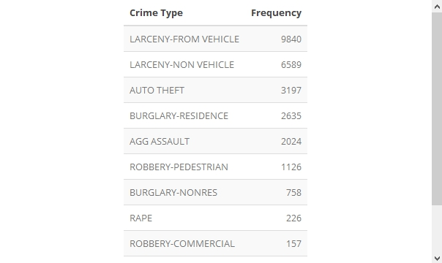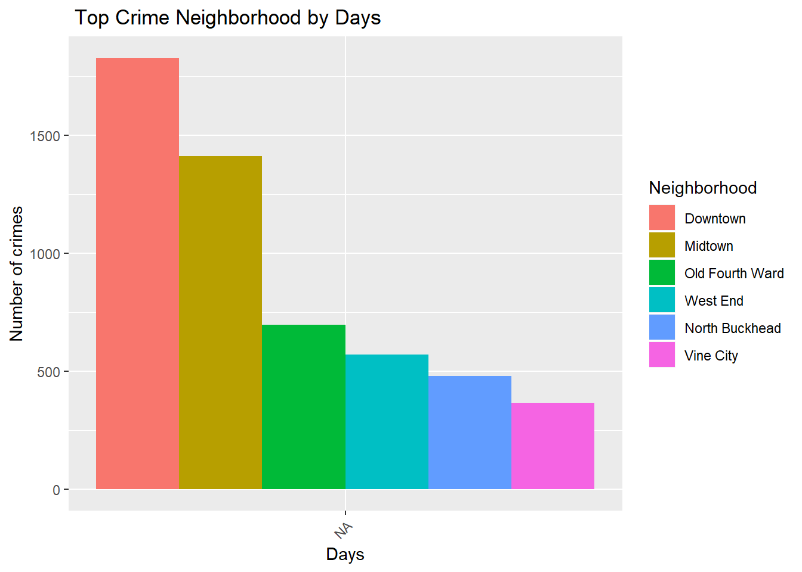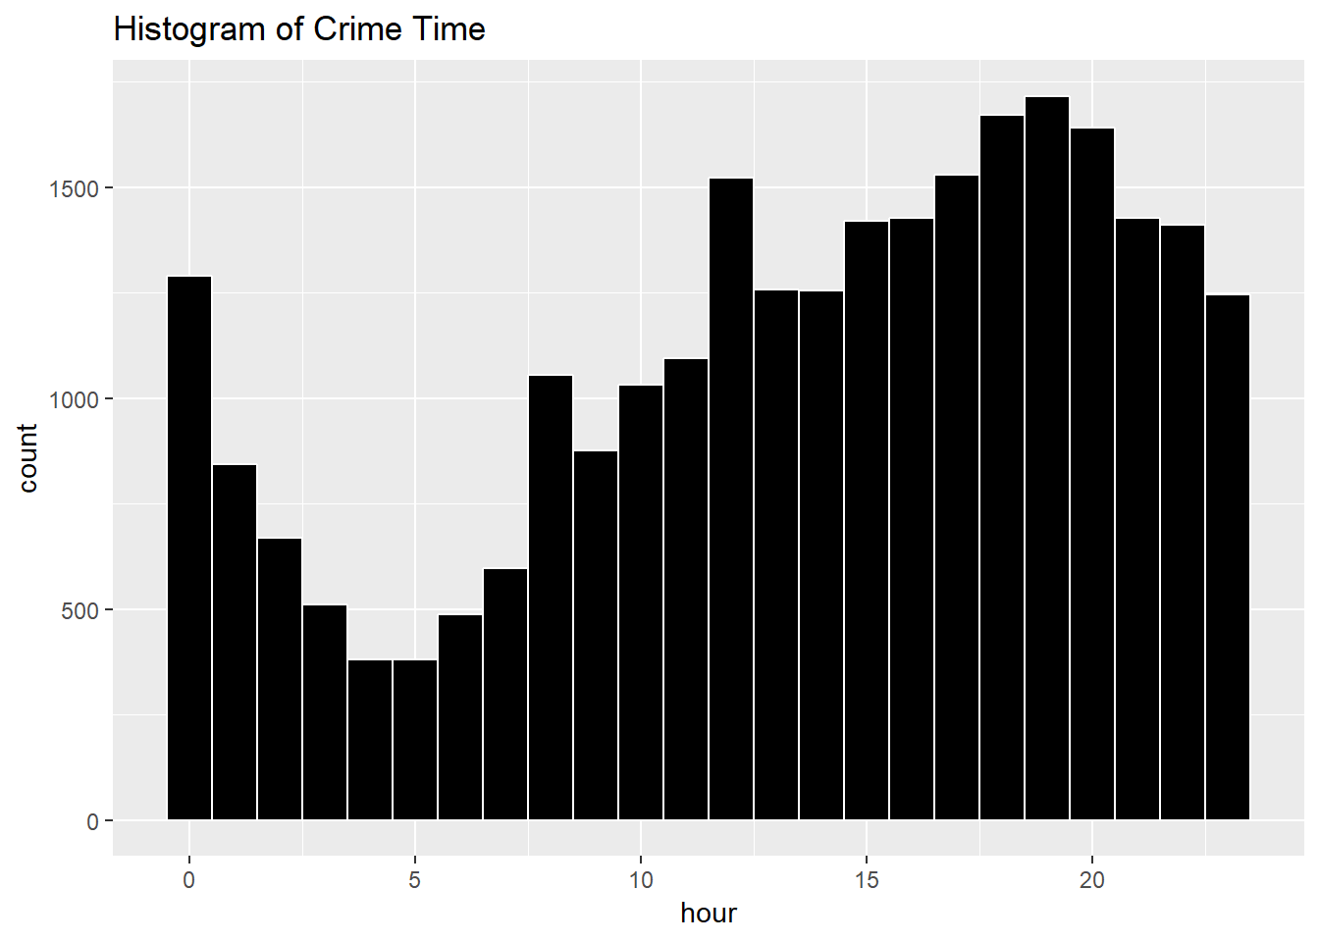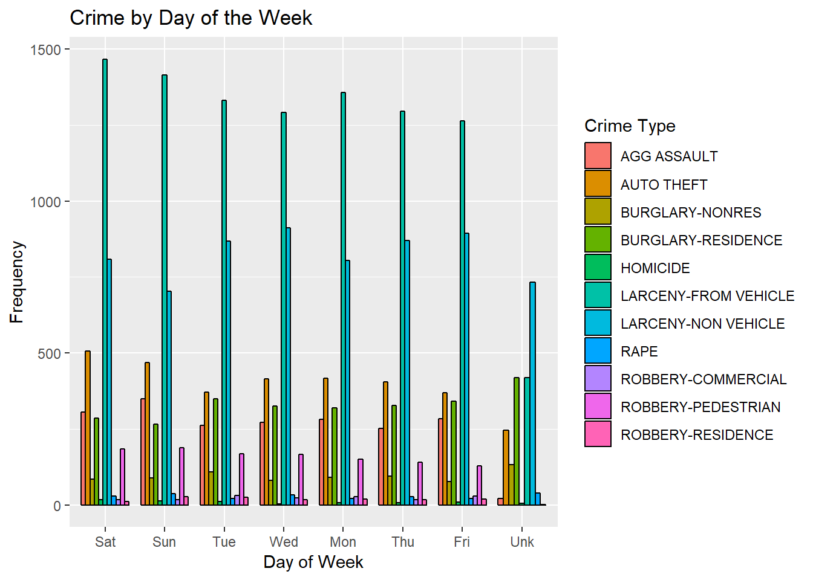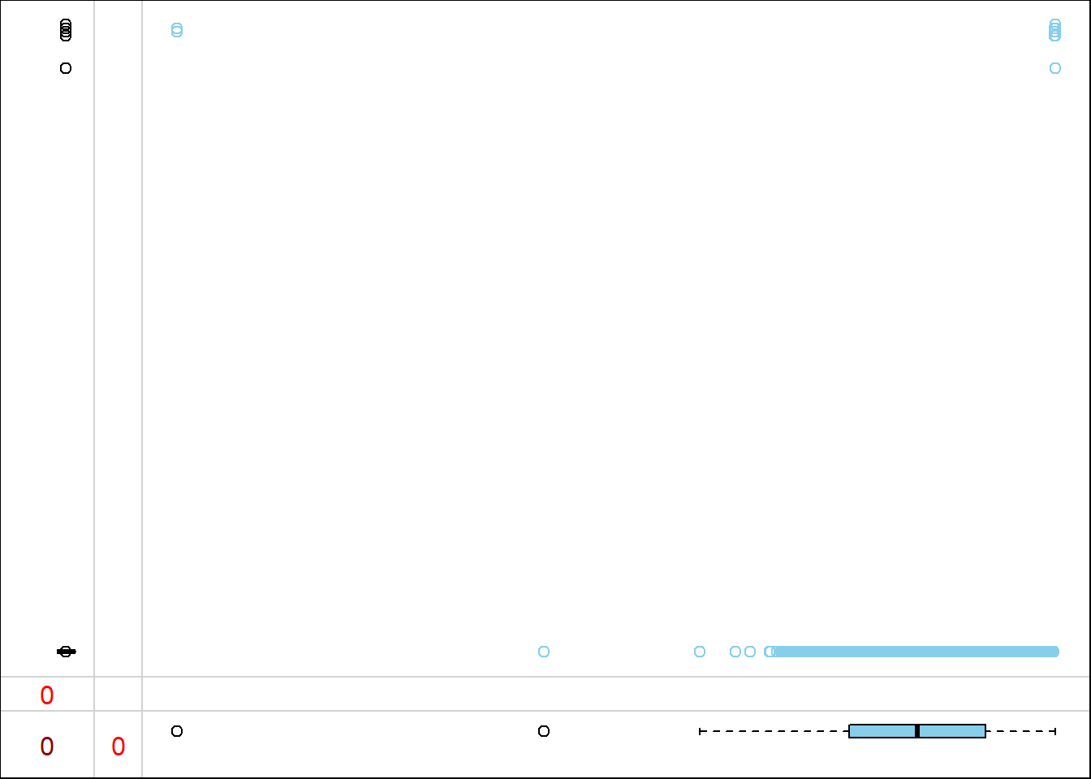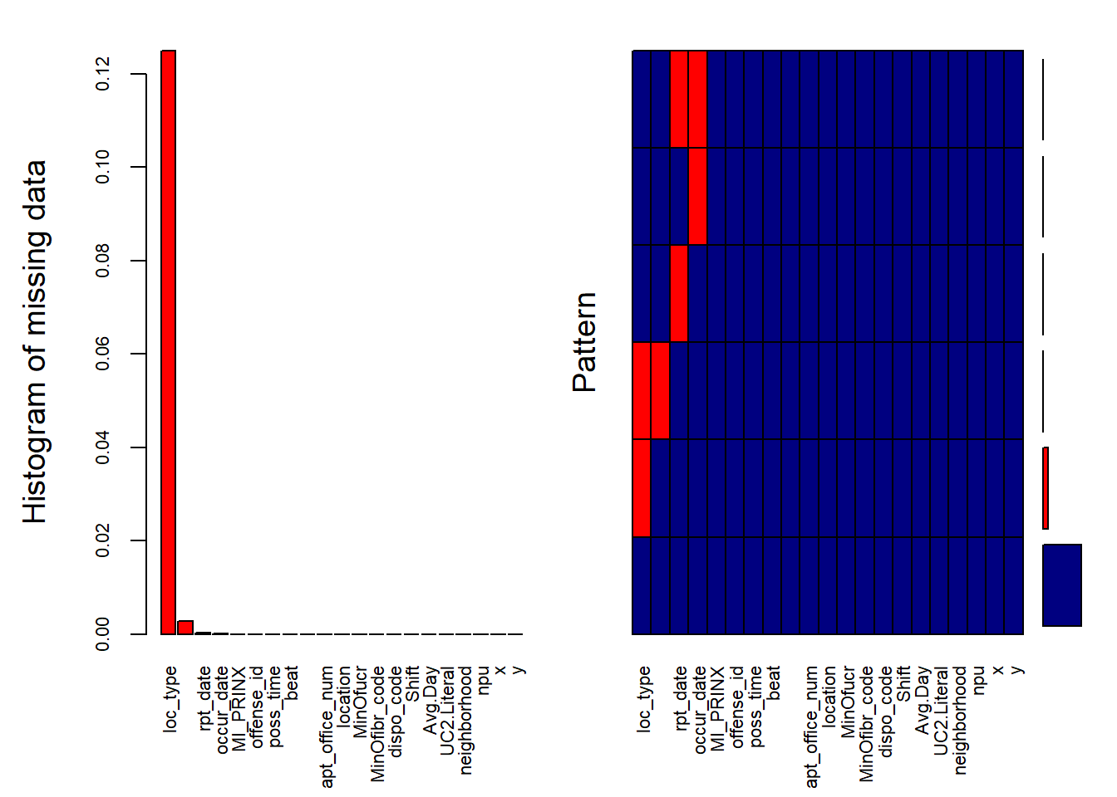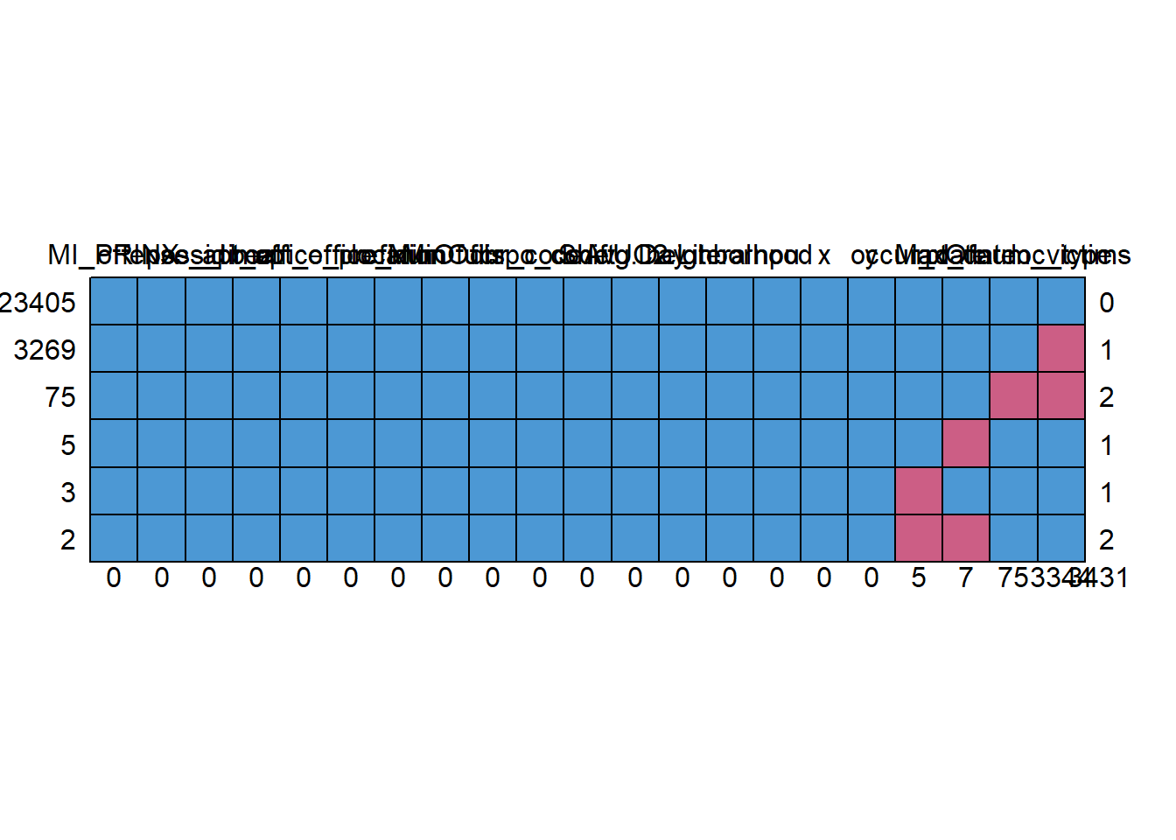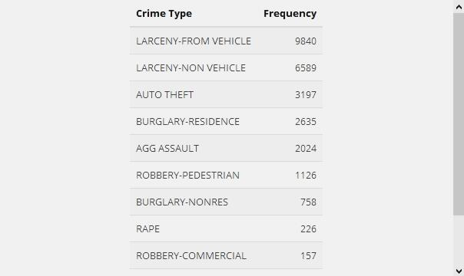

**Time series graphs for crime during the period**

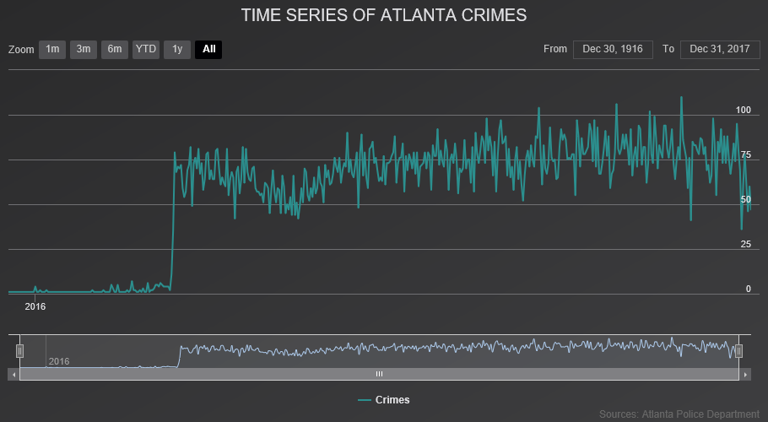

What is the difference between co-variance and correlation? Take an example from this dataset and show the differences if any?

**Covariance** and **Correlation** are two mathematical concepts which are quite commonly used in business statistics. Both of these two determine the relationship and measures the dependency between two random variables. Despite, some similarities between these two mathematical terms, they are different from each other. Correlation is when the change in one item may result in the change in another item.

Correlation is considered as the best tool for for measuring and expressing the quantitative relationship between two variables in formula. On the other hand, covariance is when two items vary together. Read the given article to know the differences between covariance and correlation.

| **BASIS FOR COMPARISON** | **COVARIANCE** | **CORRELATION** |
| --- | --- | --- |
| Meaning | Covariance is a measure indicating the extent to which two random variables change in tandem. | Correlation is a statistical measure that indicates how strongly two variables are related. |
| What is it? | Measure of correlation | Scaled version of covariance |
| Values | Lie between -∞ and +∞ | Lie between -1 and +1 |
| Change in scale | Affects covariance | Does not affects correlation |
| Unit free measure | No | Yes |

### Similarities

Both measures only linear relationship between two variables, i.e. when the correlation coefficient is zero, covariance is also zero. Further, the two measures are unaffected by the change in location.

Correlation is a special case of covariance which can be obtained when the data is standardized. Now, when it comes to making a choice, which is a better measure of the relationship between two variables*, correlation is preferred over covariance, because it remains unaffected by the change in location and scale, and can also be used to make a comparison between two pairs of variables.*

**Take an example from this dataset and show the differences if any?**

#Correlation & covariance

#Correlation & covariance

cor(COBRA_YTD2017$x,COBRA_YTD2017$y)

cov(COBRA_YTD2017$x,COBRA_YTD2017$y)

cor.test(COBRA_YTD2017$x,COBRA_YTD2017$y)

cor(COBRA_YTD2017$long,COBRA_YTD2017$lat)

cor.test(COBRA_YTD2017$long,COBRA_YTD2017$lat)

cov(COBRA_YTD2017$long,COBRA_YTD2017$lat)

plot(COBRA_YTD2017$x,COBRA_YTD2017$y)

mod=lm(COBRA_YTD2017$long~COBRA_YTD2017$lat)

summary(mod)

predict(mod)

pred= predict(mod)

COBRA_YTD2017$predicted=NA

COBRA_YTD2017$predicted=pred

COBRA_YTD2017$error=COBRA_YTD2017$residuals

library(car)

dwt(mod)

plot(COBRA_YTD2017$long,COBRA_YTD2017$lat,abline(COBRA_YTD2017$long~COBRA_YTD2017$lat),col='red')

**[1] -0.9998355**

**[1] -23.86342**

Pearson's product-moment correlation

data: COBRA_YTD2017$x and COBRA_YTD2017$y

t = -9017.2, df = 26757, p-value < 2.2e-16

alternative hypothesis: true correlation is not equal to 0

95 percent confidence interval:

-0.9998394 -0.9998315

sample estimates:

cor

-0.9998355

[1] -0.9998355

Pearson's product-moment correlation

data: COBRA_YTD2017$long and COBRA_YTD2017$lat

t = -9017.2, df = 26757, p-value < 2.2e-16

alternative hypothesis: true correlation is not equal to 0

95 percent confidence interval:

-0.9998394 -0.9998315

sample estimates:

cor

-0.9998355

[1] -23.86342

156 157 158 159 160

-84.42579683 -84.51468279 -84.35395817 -84.32176325 -84.62601522

161 162 163 164 165

-84.24112598 -84.34355981 -84.61686666 -84.52210662 -84.55457650

166 167 168 169 170

-84.41107415 -84.52540610 -84.43749498 -84.36698111 -84.53340484

171 172 173 174 175

-84.31936363 -84.41764811 -84.43677009 -84.36185692 -84.47736369

176 177 178 179 180

-84.42814646 -84.39302700 -84.11039662 -84.14436626 -84.41507352

181 182 183 184 185

-84.41789807 -84.39345193 -84.35360822 -84.39540163 -84.39000248

186 187 188 189 190

-84.31583919 -84.30746551 -84.54732764 -84.49833538 -84.40007589

191 192 193 194 195

-84.57079894 -84.27072131 -84.38625307 -84.52508115 -84.29791702

196 197 198 199 200

-84.38047898 -84.51438284 -84.19998248 -84.40202558 -84.27777020

201 202 203 204 205

-84.52418130 -84.35438310 -84.42687166 -84.39625149 -84.38500327

206 207 208 209 210

-0.02197167 -84.47451414 -84.48048819 -84.41507352 -84.29656723

211 212 213 214 215

-84.37737947 -84.39345193 -84.40407526 -84.39315198 -84.21048082

216 217 218 219 220

-84.29579235 -84.40952440 -84.43936968 -84.35825749 -84.35383319

221 222 223 224 225

-84.53747920 -84.53502958 -84.62551530 -84.39052740 -84.49731054

226 227 228 229 230

-84.42054766 -84.63816330 -84.53415472 -84.39392686 -84.41342378

231 232 233 234 235

-84.49196138 -84.43989460 -84.21553002 -84.40719976 -84.51833222

236 237 238 239 240

-84.41532348 -84.31583919 -84.46421576 -84.35043372 -84.41179904

241 242 243 244 245

-84.38017903 -84.26067290 -84.41802305 -84.40050082 -84.41952282

246 247 248 249 250

-84.23052765 -84.47738868 -84.49191139 -84.48818698 -84.21835458

251 252 253 254 255

-84.38622807 -84.55887582 -84.60241894 -84.32358796 -84.28719371

256 257 258 259 260

-84.27984487 -84.54230343 -84.32371294 -84.39055239 -84.41917287

261 262 263 264 265

-84.39442678 -84.45599206 -84.38162880 -84.65446073 -84.55635122

266 267 268 269 270

-84.20898106 -84.60816804 -84.45214267 -84.30629069 -84.36395659

271 272 273 274 275

-84.30826538 -84.54475305 -84.39625149 -84.56537479 -84.35955728

276 277 278 279 280

-84.31356455 -84.41579841 -84.46339089 -84.23057765 -84.28134463

281 282 283 284 285

-84.18293517 -84.19333353 -84.27127122 -84.42034769 -84.39312698

286 287 288 289 290

-84.44826828 -84.51308305 -84.41889792 -84.56869927 -84.32543767

291 292 293 294 295

-84.34570947 -84.29084313 -84.63991302 -84.45231764 -84.34728422

296 297 298 299 300

-84.40375031 -84.46004142 -84.44054450 -84.41414867 -84.32133832

301 302 303 304 305

-84.21700479 -84.62551530 -84.50588418 -84.35433311 -84.41237395

306 307 308 309 310

-84.41452361 -84.25629859 -84.68728055 -84.15311488 -84.42184745

311 312 313 314 315

-84.26084787 -84.29046819 -84.62551530 -84.64116283 -84.51833222

316 317 318 319 320

-84.35440810 -84.18495985 -84.39165222 -84.40517508 -84.34943388

321 322 323 324 325

-84.38160380 -84.27779519 -84.21553002 -84.22970278 -84.40215056

326 327 328 329 330

-84.68663065 -84.22970278 -84.22560343 -84.54260339 -84.48048819

331 332 333 334 335

-84.40395028 -84.32476278 -84.31073999 -84.38280361 -84.57717293

336 337 338 339 340

-84.63108942 -84.45221766 -84.43951966 -84.51833222 -84.46486566

341 342 343 344 345

-84.48978673 -84.38730290 -84.43127096 -84.41257391 -84.41969779

346 347 348 349 350

-84.44914314 -84.41184903 -84.53003037 -84.33776073 -84.40410025

351 352 353 354 355

-84.55367664 -84.55750104 -84.48253787 -84.68920524 -84.56992407

356 357 358 359 360

-84.44214425 -84.56907421 -84.31683903 -84.36780598 -84.48018824

361 362 363 364 365

-84.41479856 -84.25817329 -84.44739342 -84.49701058 -84.35080867

366 367 368 369 370

-84.59796965 -84.49233632 -84.28214451 -84.62551530 -84.17831090

371 372 373 374 375

-84.51833222 -84.40050082 -84.52305647 -84.41404868 -84.26879661

376 377 378 379 380

-84.40050082 -84.31738894 -84.62551530 -84.40337537 -84.41784808

381 382 383 384 385

-84.51183324 -84.61924129 -84.39072736 -84.59854456 -84.45254260

386 387 388 389 390

-84.44069448 -84.39145225 -84.24954965 -84.37987908 -84.57672300

391 392 393 394 395

-84.44284414 -84.26667195 -84.40262549 -84.63016456 -84.43989460

396 397 398 399 400

-84.36748103 -84.62066606 -84.70332801 -84.31468937 -84.55627623

401 402 403 404 405

-84.44179430 -84.41449861 -84.46544057 -84.38017903 -84.44494380

406 407 408 409 410

-84.49191139 -84.46079130 -84.42114756 -84.44831827 -84.36680614

411 412 413 414 415

-84.41889792 -84.55887582 -84.23717660 -84.32443783 -84.16458806

416 417 418 419 420

-84.39820118 -84.34548451 -84.46381583 -84.39162722 -84.46171616

421 422 423 424 425

-84.40977436 -84.33368637 -84.46506563 -84.21700479 -84.53875399

426 427 428 429 430

-84.31786387 -84.38760286 -84.39100232 -84.42057265 -84.36668116

431 432 433 434 435

-84.40322539 -84.38347851 -84.27612046 -84.47823855 -84.39622650

436 437 438 439 440

-84.28366926 -84.10247287 -84.61531691 -84.56557476 -84.29739210

441 442 443 444 445

-84.27817013 -84.37747946 -84.45769179 -84.40487513 -84.47823855

446 447 448 449 450

-84.57097391 -84.45919156 -84.18293517 -84.45176773 -84.44466885

451 452 453 454 455

-84.45334248 -84.55597628 -84.42512193 -84.54177852 -84.39942599

456 457 458 459 460

-84.37173036 -84.19158380 -84.43314567 -84.39625149 -84.14796569

461 462 463 464 465

-84.44536874 -84.35265837 -84.49811041 -84.51833222 -84.55877583

466 467 468 469 470

-84.41917287 -84.59886950 -84.56869927 -84.34913393 -84.22050424

471 472 473 474 475

-84.39477672 -84.61839142 -84.31231474 -84.62551530 -84.40217556

476 477 478 479 480

-84.43032111 -84.43841983 -84.53642936 -84.56869927 -84.53775415

481 482 483 484 485

-84.53357981 -84.35998222 -84.42507194 -84.60919287 -84.25712346

486 487 488 489 490

-84.39170221 -84.50133490 -84.39032743 -84.64116283 -84.49068658

491 492 493 494 495

-84.37837931 -84.64983646 -84.43117098 -84.43514535 -84.57097391

496 497 498 499 500

-0.02197167 -84.38667800 -84.42582182 -84.38737789 -84.18293517

501 502 503 504 505

-84.29589234 -84.29046819 -84.28134463 -84.36815593 -84.53457965

506 507 508 509 510

-84.42189744 -84.30731553 -84.42314725 -84.19020902 -84.38095391

511 512 513 514 515

-84.40634990 -84.38935258 -84.31528927 -84.35443309 -84.42132253

516 517 518 519 520

-84.37710451 -84.40357534 -84.41854797 -84.23755155 -84.35443309

521 522 523 524 525

-84.44256918 -84.27944493 -84.52678088 -84.43289571 -84.38900264

526 527 528 529 530

-84.48018824 -84.30391607 -84.42814646 -84.33518613 -84.68013168

531 532 533 534 535

-84.41644830 -84.34403474 -84.40050082 -84.39625149 -84.55427654

536 537 538 539 540

-84.62536532 -84.35443309 -84.23450203 -84.48341273 -84.39345193

541 542 543 544 545

-84.62551530 -84.54485303 -84.53080525 -84.62751498 -84.35295833

546 547 548 549 550

-84.41754813 -84.51833222 -84.41739815 -84.46331590 -84.62579025

551 552 553 554 555

-84.36568132 -84.54340326 -84.41439863 -84.15229001 -84.14786570

556 557 558 559 560

-84.40050082 -84.40050082 -84.26562211 -84.63816330 -84.22560343

561 562 563 564 565

-84.35998222 -84.15881398 -84.48253787 -84.70070343 -84.40050082

566 567 568 569 570

-84.41832301 -84.38107889 -84.41384871 -84.63991302 -84.47026481

571 572 573 574 575

-84.48346272 -84.45249261 -84.21553002 -84.45889160 -84.41917287

576 577 578 579 580

-84.47493907 -84.62551530 -84.61839142 -84.25734842 -84.45889160

581 582 583 584 585

-84.35118361 -84.39640147 -84.60261891 990

-84.43074605 -84.63256418 -84.45636700 -84.52885556 -84.11329616

991 992 993 994 995

-84.41797306 -84.54272837 -84.56177536 -84.63261418 -84.38785282

996 997 998 999 1000

-84.39625149 -84.36688113 -84.44059449 -84.45641699 -84.17181192

[ reached get Option("max.print") -- omitted 25759 entries ]

lag Autocorrelation D-W Statistic p-value

1 0.02809992 1.943799 0

Alternative hypothesis: rho != 0

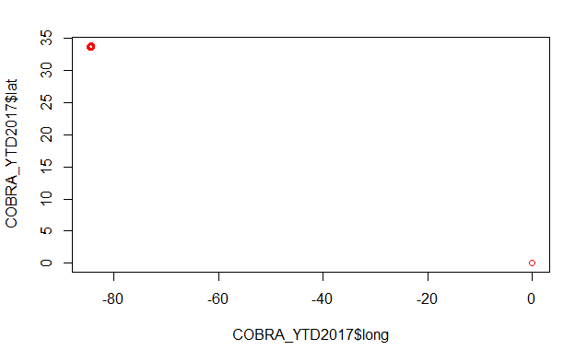

R Markdown

This is an R Markdown document. Markdown is a simple formatting syntax for authoring HTML, PDF, and MS Word documents. For more details on using R Markdown see [http://rmarkdown.rstudio.com](http://rmarkdown.rstudio.com/).

When you click the **Knit** button a document will be generated that includes both content as well as the output of any embedded R code chunks within the document. You can embed an R code chunk like this:

summary(cars)

## speed dist

## Min. : 4.0 Min. : 2.00

## 1st Qu.:12.0 1st Qu.: 26.00

## Median :15.0 Median : 36.00

## Mean :15.4 Mean : 42.98

## 3rd Qu.:19.0 3rd Qu.: 56.00

## Max. :25.0 Max. :120.00

Including Plots

You can also embed plots, for example:

Note that the echo = FALSE parameter was added to the code chunk to prevent printing of the R code that generated the plot.